Remote Procedure call (RPC)

introduction
The idea behind Remote Procedure Call (RPC) is to allow a program running on a specific device (client) to call a procedure located on another device (server), as if this procedure were part of the program itself. In this type of communication, the client sends the required data to the server over the network, and the server performs the required operation and returns the result to the client as if it were a return value of a normal function.
This method makes communication between devices simple and is very similar to calling procedures within the same program, even though the operation is actually performed over a network connection using sockets.
In this lab, we will apply the concept of RPC in a simplified way, where the client sends two numbers to the server, while the server performs the requested action, which is to add the two numbers and then return the result to the client.

GreetingClient – Code Explanation
The program asks the user to enter the server address (IP address) and port number, and This information is required by the client in order to connect to the server:
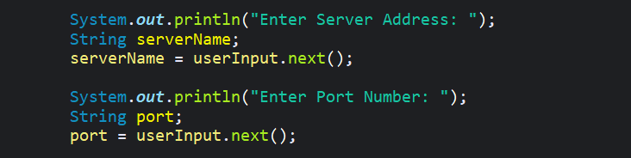

This line establishes a TCP connection with the server using the IP and port. If the connection is successful, “Just connected” will appear:

Here, a DataOutputStream is created to facilitate sending numbers directly in int format over the network:
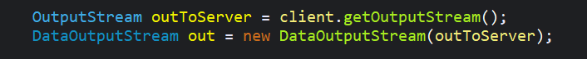

Take the two numbers from the user and send them to the server:
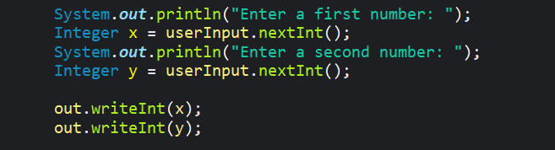

The client waits for the result from the server, and after completion, the connection is closed:
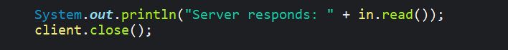

GreetingServer – Code Explanation
Creating ServerSocket: The server opens a port and starts waiting for clients. A timeout is set so that it does not wait forever:
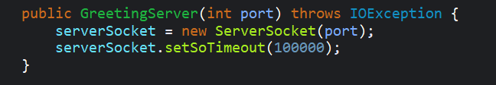

The server receives the first number, then prints “Hellox,” then receives the second number, then prints “Helloy.” This confirms that the data has arrived from the client:
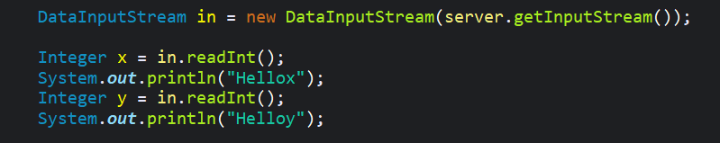
The server collects the two numbers, sends the result to the client, and then closes the connection with the client after sending the result:
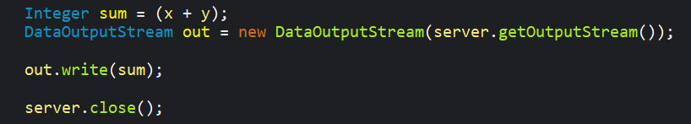

Example:
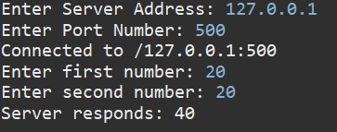

If you would like to view the full code, you can visit the project link on my GitHub account via the attached link: https://github.com/Khalid0415/Remote-Procedure-Call-RPC---example

